Capstone Project Part-2 (API Implement)

PROJECT PACKAGE STRUCTURE
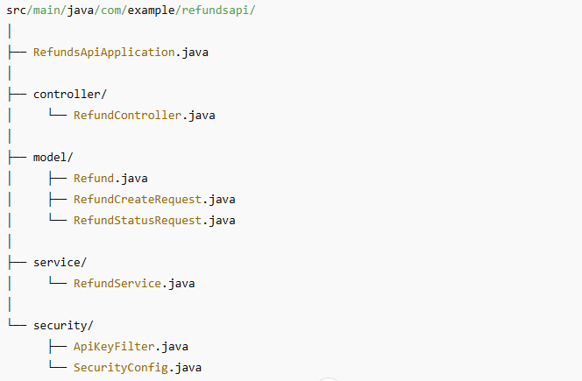

- Spring Initializr (recommended)

Open https://start.spring.io/

• Project: Maven Project
• Language: Java
• Spring Boot: latest 3.x (e.g. 3.2.x)
• Group: com.example
• Artifact: refundsapi
• Dependencies:
- Spring Web
- Spring Security
- lombok

2. Model Classes

2.1 Refund.java
package com.example.refundsapi.model;

import lombok.AllArgsConstructor;
import lombok.Data;
import lombok.NoArgsConstructor;

@Data
@AllArgsConstructor
@NoArgsConstructor
public class Refund {

private String id;
private double amount;
private String currency;
private String reason;
private String status;
}

2.2 RefundCreateRequest.java
package com.example.refundsapi.model;

import lombok.Data;

@Data
public class RefundCreateRequest {

private double amount;
private String currency;
private String reason;
}

2.3 RefundStatusRequest.java
package com.example.refundsapi.model;

import lombok.Data;

@Data
public class RefundStatusRequest {

private String refundId;
}

3. Service Layer

3.1 RefundService.java
package com.example.refundsapi.service;

import com.example.refundsapi.model.Refund;
import com.example.refundsapi.model.RefundCreateRequest;
import com.example.refundsapi.model.RefundStatusRequest;
import org.springframework.stereotype.Service;

import java.util.*;

@Service
public class RefundService {

private final Map<String, Refund> store = new HashMap<>();

public Refund createRefund(RefundCreateRequest req) {
String id = UUID.randomUUID().toString();

Refund refund = new Refund(
id,
req.getAmount(),
req.getCurrency(),
req.getReason(),
"PENDING"
);

store.put(id, refund);
return refund;
}

public Refund getRefund(String id) {
return Optional.ofNullable(store.get(id))
.orElseThrow(() -> new RuntimeException("Refund Not Found"));
}

public Refund checkStatus(String id) {
return getRefund(id);
}

public List<Refund> getAll() {
return new ArrayList<>(store.values());
}
}

4. Controller Layer

4.1 RefundController.java
package com.example.refundsapi.controller;

import com.example.refundsapi.model.Refund;
import com.example.refundsapi.model.RefundCreateRequest;
import com.example.refundsapi.model.RefundStatusRequest;
import com.example.refundsapi.service.RefundService;

import org.springframework.beans.factory.annotation.Autowired;
import org.springframework.http.ResponseEntity;
import org.springframework.web.bind.annotation.*;

import java.util.List;

@RestController
@RequestMapping("/refunds")
public class RefundController {

@Autowired
private RefundService service;

@GetMapping
public List<Refund> getAllRefunds() {
return service.getAll();
}

@PostMapping
public ResponseEntity<Refund> createRefund(@RequestBody RefundCreateRequest req) {
return ResponseEntity.status(201).body(service.createRefund(req));
}

@GetMapping("/{id}")
public Refund getRefundById(@PathVariable String id) {
return service.getRefund(id);
}

@PostMapping("/status")
public Refund getStatus(@RequestBody RefundStatusRequest req) {
return service.checkStatus(req.getRefundId());
}
}

5. Security Layer

5.1 ApiKeyFilter.java
package com.example.refundsapi.security;

import jakarta.servlet.FilterChain;
import jakarta.servlet.ServletException;
import jakarta.servlet.http.HttpServletRequest;
import jakarta.servlet.http.HttpServletResponse;

import org.springframework.stereotype.Component;
import org.springframework.web.filter.OncePerRequestFilter;

import java.io.IOException;

@Component
public class ApiKeyFilter extends OncePerRequestFilter {

private static final String TOKEN = "my-secret-token";

@Override
protected void doFilterInternal(
HttpServletRequest request,
HttpServletResponse response,
FilterChain chain
) throws ServletException, IOException {

String header = request.getHeader("Authorization");

if (header == null || !header.equals("Bearer " + TOKEN)) {
response.setStatus(HttpServletResponse.SC_UNAUTHORIZED);
response.getWriter().write("Unauthorized");
return;
}

chain.doFilter(request, response);
}
}

5.2 SecurityConfig.java
package com.example.refundsapi.security;
import org.springframework.beans.factory.annotation.Autowired;
import org.springframework.context.annotation.Bean;
import org.springframework.context.annotation.Configuration;
import org.springframework.security.config.annotation.web.builders.HttpSecurity;
import org.springframework.security.web.SecurityFilterChain;
import org.springframework.security.web.authentication.UsernamePasswordAuthenticationFilter;
@Configuration
public class SecurityConfig {
@Autowired
private ApiKeyFilter apiKeyFilter;
@Bean
public SecurityFilterChain securityFilterChain(HttpSecurity http) throws Exception {
return http
.csrf(csrf -> csrf.disable()) // ← FIX CSRF for POST
.authorizeHttpRequests(auth -> auth
.requestMatchers("/refunds/**").permitAll() // Allow API calls but protected by filter
.anyRequest().authenticated()
)
.addFilterBefore(apiKeyFilter, UsernamePasswordAuthenticationFilter.class)
.build();
}
}

A. pom.xml
<?xml version="1.0" encoding="UTF-8"?>
<project xmlns="http://maven.apache.org/POM/4.0.0" xmlns:xsi="http://www.w3.org/2001/XMLSchema-instance"
xsi:schemaLocation="http://maven.apache.org/POM/4.0.0 https://maven.apache.org/xsd/maven-4.0.0.xsd">
<modelVersion>4.0.0</modelVersion>
<parent>
<groupId>org.springframework.boot</groupId>
<artifactId>spring-boot-starter-parent</artifactId>
<version>3.5.7</version>
<relativePath/> <!-- lookup parent from repository -->
</parent>
<groupId>com.example</groupId>
<artifactId>refundsapi</artifactId>
<version>0.0.1-SNAPSHOT</version>
<name>refundsapi</name>
<description>Demo project for Spring Boot</description>
<url/>
<licenses>
<license/>
</licenses>
<developers>
<developer/>
</developers>
<scm>
<connection/>
<developerConnection/>
<tag/>
<url/>
</scm>
<properties>
<java.version>17</java.version>
</properties>
<dependencies>
<dependency>
<groupId>org.springframework.boot</groupId>
<artifactId>spring-boot-starter-web</artifactId>
</dependency>
<dependency>
<groupId>org.projectlombok</groupId>
<artifactId>lombok</artifactId>
<optional>true</optional>
</dependency>
<dependency>
<groupId>org.springframework.boot</groupId>
<artifactId>spring-boot-starter-security</artifactId>
</dependency>
<dependency>
<groupId>org.springframework.boot</groupId>
<artifactId>spring-boot-starter-test</artifactId>
<scope>test</scope>
</dependency>
</dependencies>
<build>
<plugins>
<plugin>
<groupId>org.apache.maven.plugins</groupId>
<artifactId>maven-compiler-plugin</artifactId>
<configuration>
<annotationProcessorPaths>
<path>
<groupId>org.projectlombok</groupId>
<artifactId>lombok</artifactId>
</path>
</annotationProcessorPaths>
</configuration>
</plugin>
<plugin>
<groupId>org.springframework.boot</groupId>
<artifactId>spring-boot-maven-plugin</artifactId>
<configuration>
<excludes>
<exclude>
<groupId>org.projectlombok</groupId>
<artifactId>lombok</artifactId>
</exclude>
</excludes>
</configuration>
</plugin>
</plugins>
</build>
</project>

